Chapter 17, Solution 39.

If the periodic voltage in Fig. 17.75(a) is applied to the circuit in Fig. 17.75(b), find i_{o}(t).

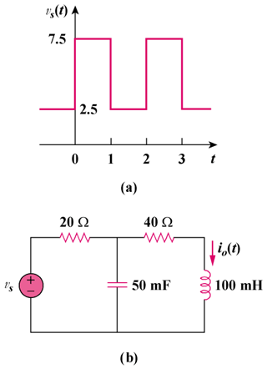

Figure 17.75
For Prob. 17.39.

Solution

Comparing v_{s}(t) with f(t) in Figure 15.1, v_{s} is shifted by 2.5 and the magnitude is 5 times that of f(t).
Hence
v_{s}(t) = n = 2k − 1

T = 2, ω_{o} = 2π//T = π, ω_{n} = nω_{o} = nπ

For the DC component, i_{o} = 5/(20 + 40) = 1/12

For the kth harmonic, V_{s} = (10/(nπ))∠0°

100 mH becomes jω_{n}L = jnπx0.1 = j0.1nπ
50 mF becomes 1/(jω_{n}C) = −j20/(nπ)

40 Ω

Z

I_{o}

I
j0.1nπ

V_{S}

+
−

20 Ω
−j20/(nπ)

Let Z = −j20/(nπ)||(40 + j0.1nπ) =

=
Z_{in} = 20 + Z =
I =
I_{o} =

=

=
Thus
i_{o}(t) = , n = 2k − 1

where

I_{n} =

